YD-FSJQL300 | 400 | 500 | 600 | 800
YD-FSJQL300 | YD-FSJQL400 | YD-FSJQL500 | YD-FSJQL600
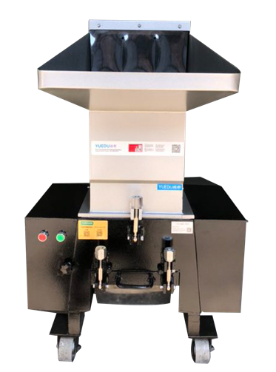 | 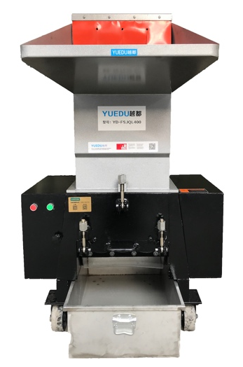 | 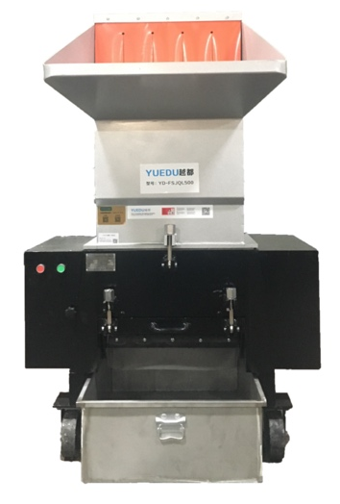 | 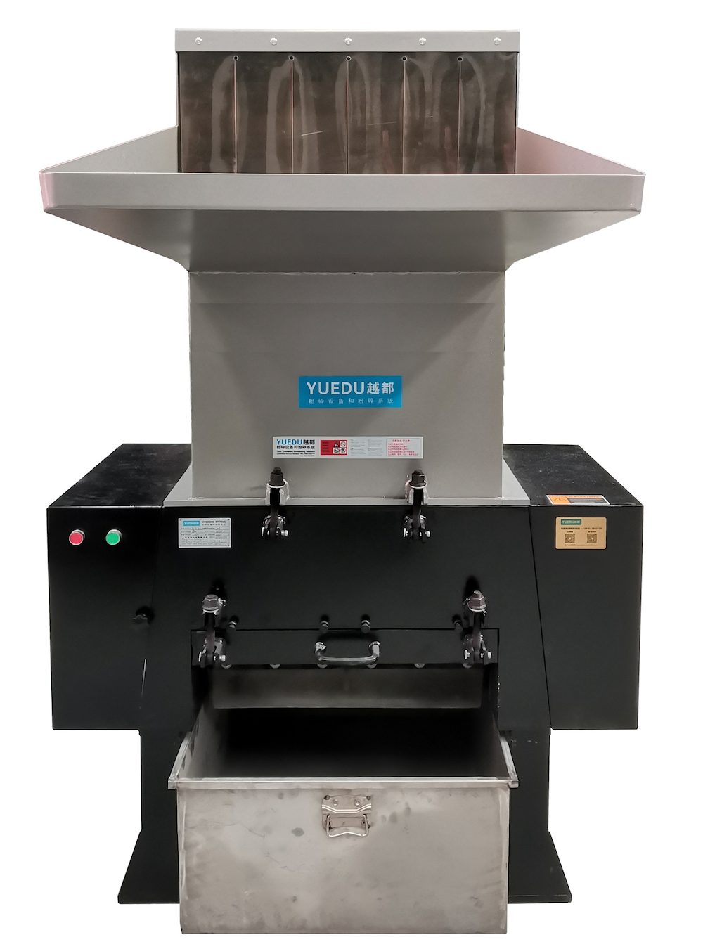
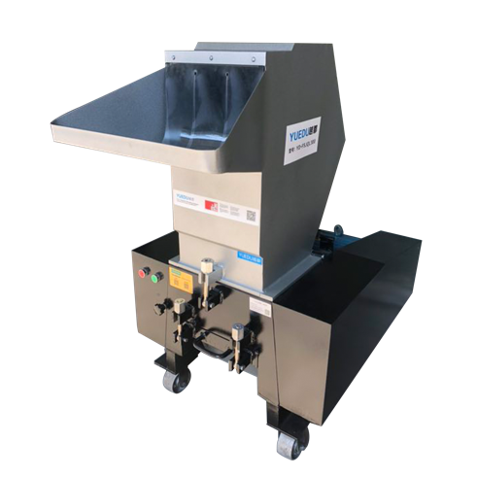 | 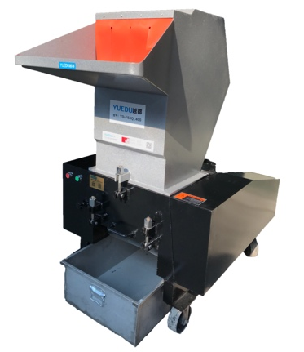 | 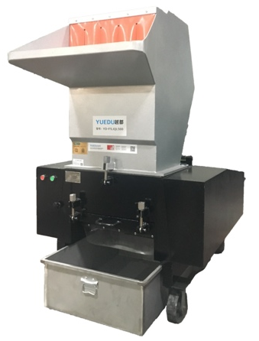 | 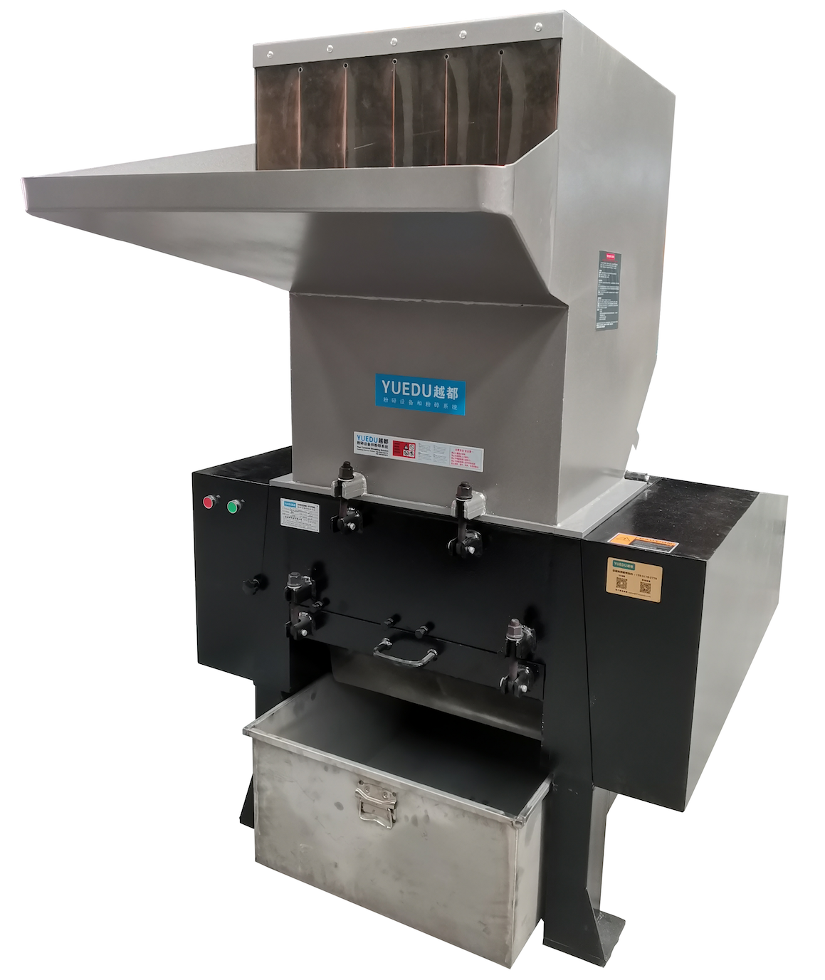
Constructed with specialized wear-resistant steel, this innovative design guarantees unmatched bite force, exceptional durability, and an extended service life. The oversized inertia wheel amplifies torque and maximizes capacity, ensuring peak performance under demanding conditions.

Technical Specifications:
Product Model | YD-FSJQL300 | YD-FSJQL400 | YD-FSJQL500 | YD-FSJQL600 | YD-FSJQL800
Inlet Dimensions (mm) | 310*260 | 410*260 | 510*260 | 610*310 | 810*410
Number of Sheets Shredded | 30-50 | 70-80 | 100-150 | 200-300 | 400-800
Shredding Capacity（kg/h） | 100-200 | 150-250 | 200-350 | 300-600 | 500-800
Motor Power | 5.5KW, 380V | 7.5KW, 380V | 11KW, 380V | 15KW, 380V | 30KW, 380V
Shredded Size(Customizable) | 8mm | 8mm | 8mm | 8mm | 8mm
Dimensions (m) | 1.22x0.72x1.16 | 1.32x0.86x1.46 | 1.45x1.00x1.54 | 1.70x1.15x1.88 | 2.22x1.38x2.38
Weight (kg) | 450 | 550 | 750 | 850 | 2000
Pricing RMB | 11765 | 15261 | 19792 | 31423 | 79618

For Long-Term Operation: Feed materials evenly and wait until the materials in the shredding chamber are fully processed before adding more. For continuous feeding, ensure each batch is no more than one-third of the value specified in the table.
Shredding Capacity: The listed capacity is the maximum, applicable to hard plastics. For materials like paper, the shredding capacity decreases and depends on the output size (larger sizes process faster). For shredding paper, a 3 cm output size is recommended for faster processing.
Customizable Sizes: Available in 1mm, 3mm, and 5mm specifications. For additional options, please contact customer service.

