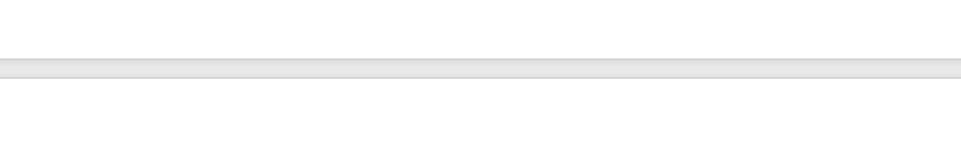

model YD-PSJ300 Series
Capable of shredding financial documents, corrugated cardboard boxes, circuit boards, hard drives, mobile phones, tablets, and various electronic storage media.
Widely used in pharmaceutical industries (for medicine box destruction), corporate destruction centers, large offices, archives, QC departments, for high-volume document shredding, financial voucher disposal, and centralized destruction of technical drawings.

🔄 Feeding Features

Open-Top Inlet – Large Opening, High Capacity
Easily accepts crumpled paper, packaging scraps, and bundled materials for direct dumping.
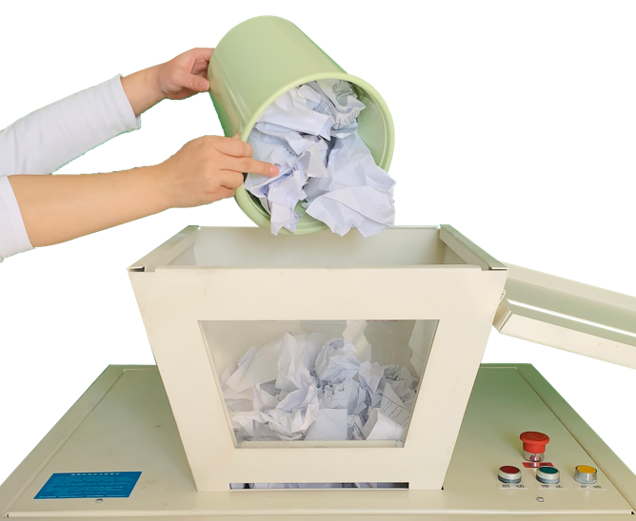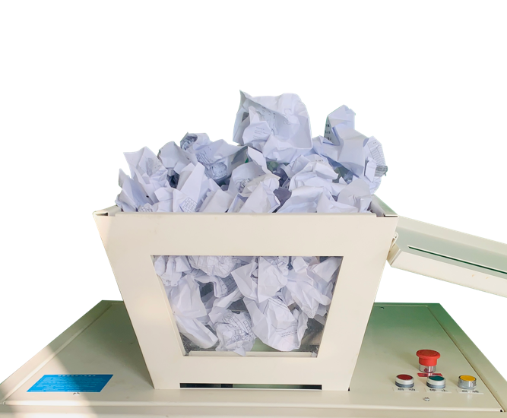
Crumpled Paper

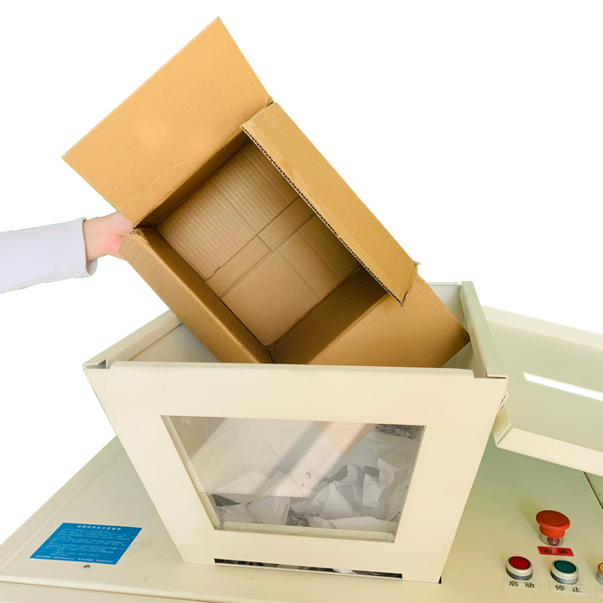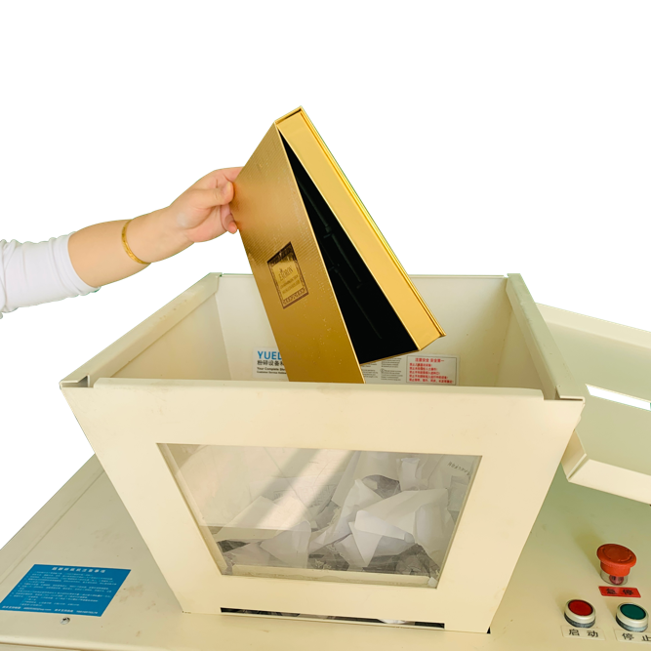
Packaging Boxes
Gift Boxes

🧿 Safety Features

Open Inlet with Safety Cover and Locking Mechanism
Equipped with secure latch;
optional key-lock retrofit available to meet safety regulations.
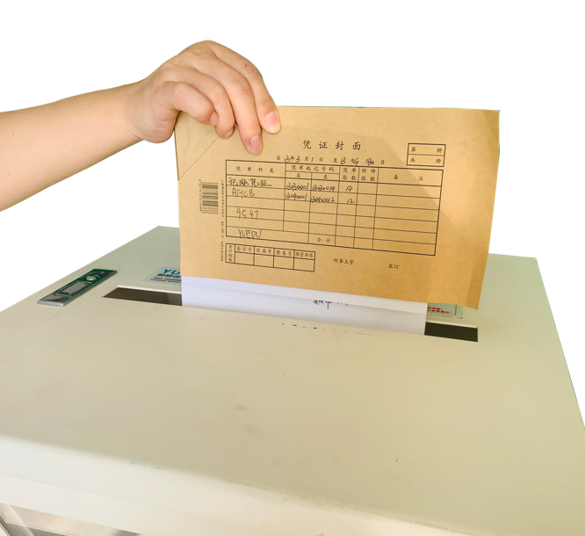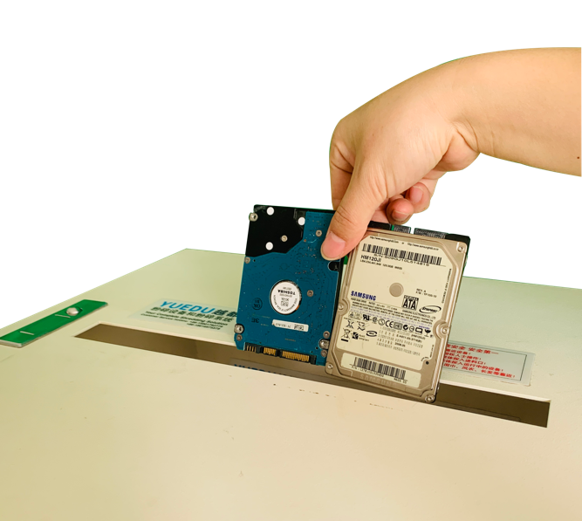
Accounting Vouchers
Hard Drives

Flat Feed Inlet –

Second Entry Point for Controlled Feeding
• Transparent Shredding Chamber for real-time operation visibility
• Multiple Safety Mechanisms:
Emergency stop switch, key lock, and compliance-ready safety options 🍭
• Flat Feed Inlet – Second Entry Point for Controlled Feeding
Designed for safe, horizontal feeding of documents and materials.

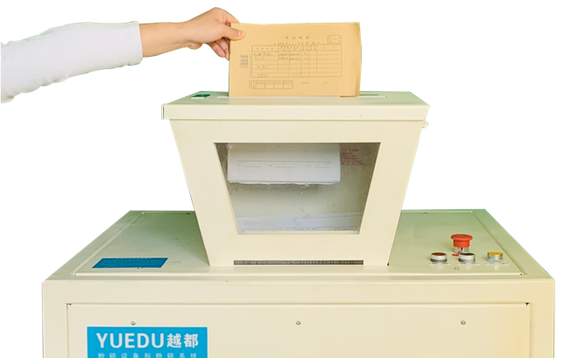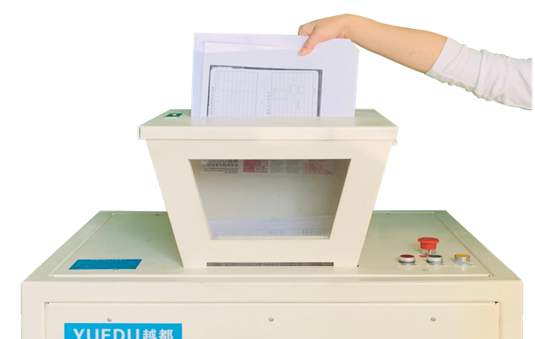

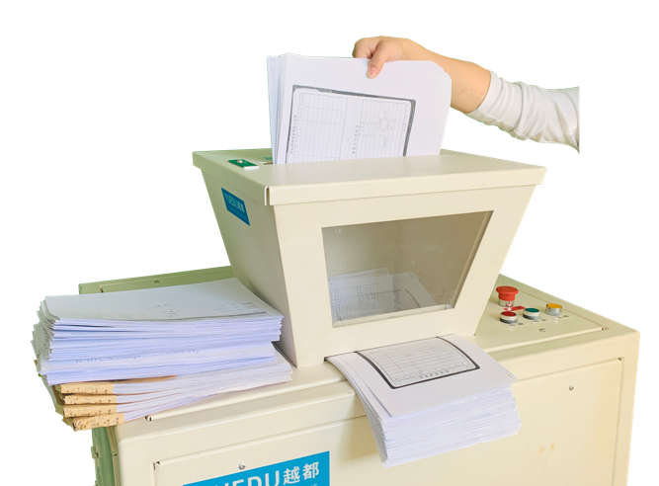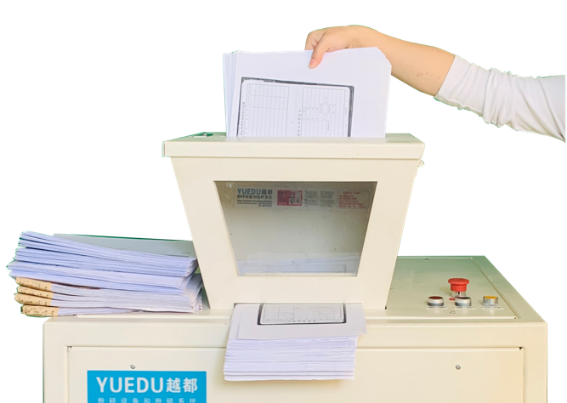

🍭 The key lock is an optional feature and can be installed based on user requirements after order confirmation.

Technical Specifications
YD-PSJ300 Series

🆔Model | YD-PSJ300 2P1.5KW | YD-PSJ300 3P2.2KW
📥Feed Width | 500*380mm | 500*380mm
✂️ Cut Size | 1*5cm | 1*5cm
📑 Max Sheets | 40-70 | 60-130
⚖️Weight (kg) | 250kg | 250kg
🔌Power | 1.5KW / 220V | 2.2KW / 3 phase 380V
🔁Continuous | 24 hours | 24 hours
📏 L×W×H (mm) | 850*700*1350mm | 850*700*1350mm
🗑️Bin(L) | Waste Chamber 400L  Waste Bin 160L | Waste Chamber 400L  Waste Bin 160L
💰Price (USD) | 5715 | 8378
🍓 Customizable sizes. Common options: 5.8×50mm, 4×40mm, 2×15mm, 1×10mm.

Machine Detail View

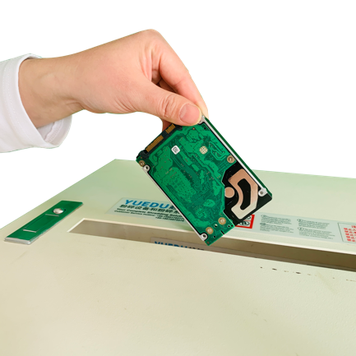 | 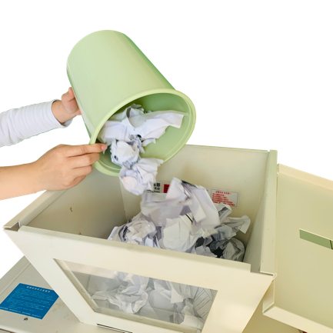 | 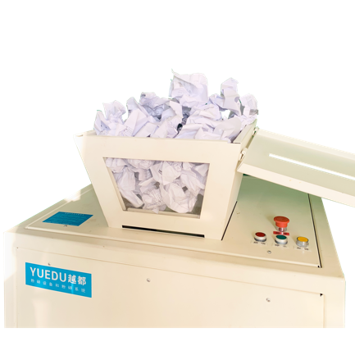
Hard Drives | Crumpled paper | Open-Top Inlet
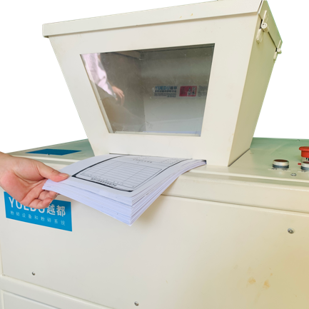 | 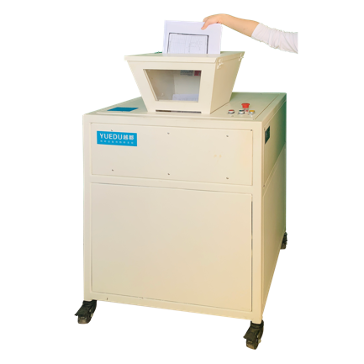 | 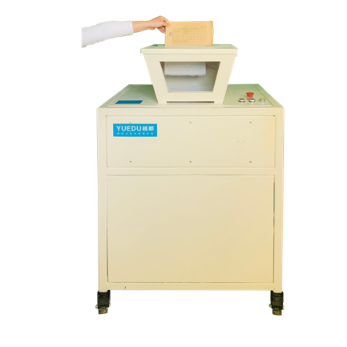
Flat feed inet | Inlet with Cover | Accounting vouchers
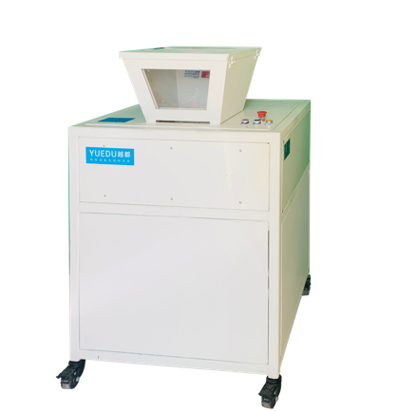 | 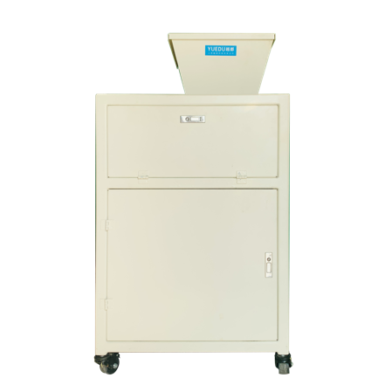 | 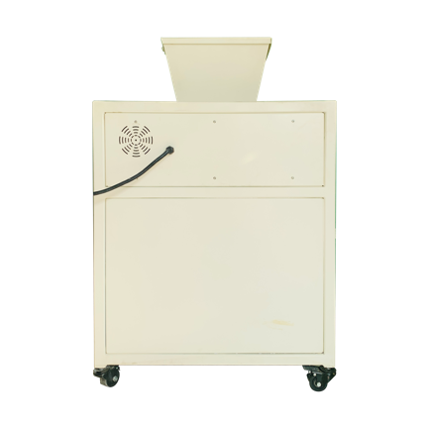
Font | Left | Back

Three-View Diagram

Fits through office doors and elevators

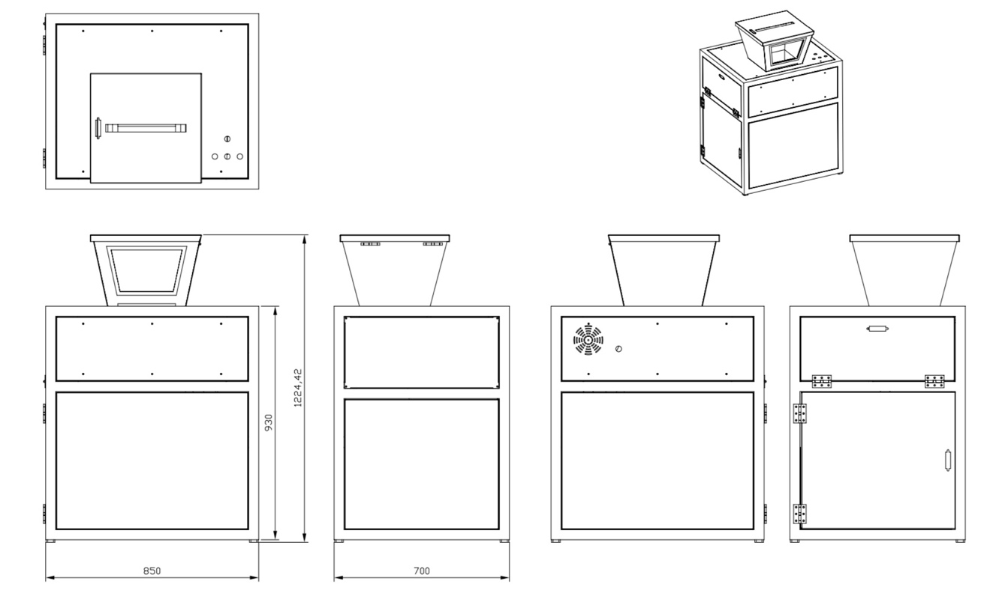
🍭 Units in three-view drawing: millimeters (mm)

🛞 Easy to Move with Swivel Casters

🚪 Fits 72cm Office & Elevator Doors

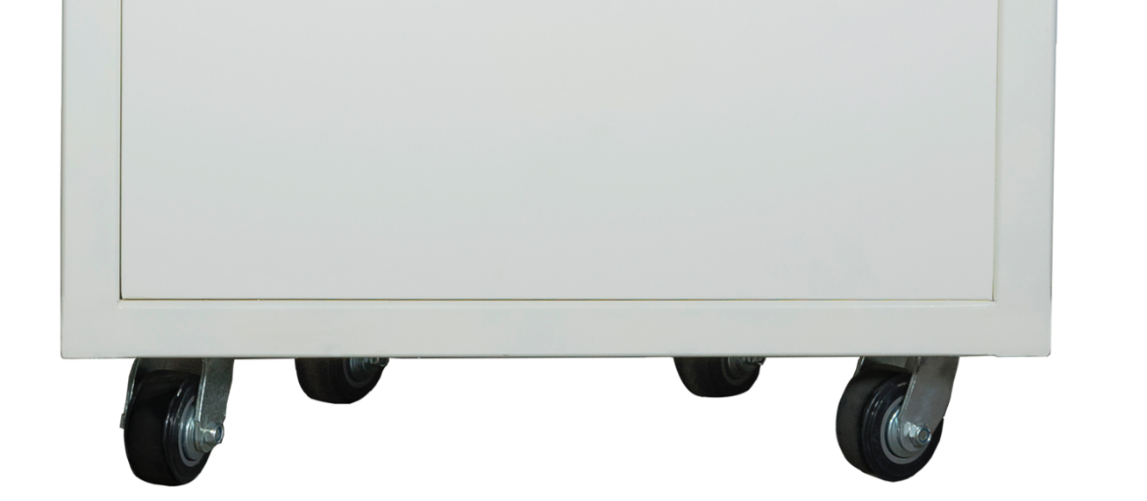

🗑️ 120L BIN

⚖️ Load Capacity

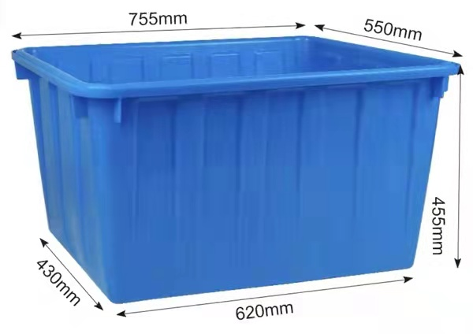
💯 160L bin standard; optional: 250L / 300L

Shredding Result
hard drives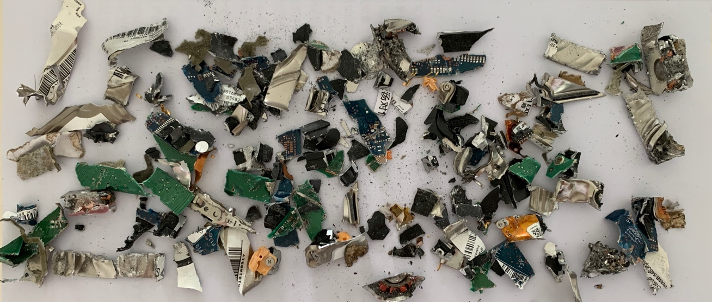

Cardboard Boxes | Film / Labels | Wood Fiberboard
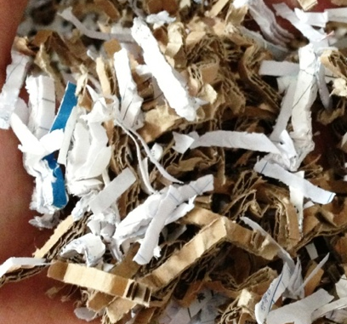 | 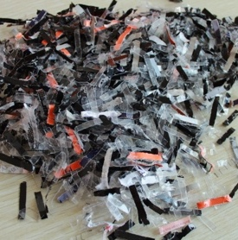 | 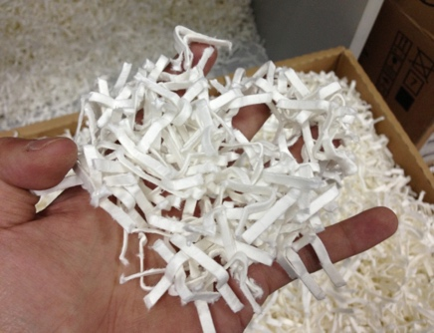
🎈 Customizable sizes. Common options: 5.8×50mm, 4×40mm, 2×15mm, 1×10mm.

Customizable sizes. Common options: 5.8×50mm, 4×40mm, 2×15mm, 1×10mm.

